CARLETON UNIVERSITY

Department of Electronics

ELEC 4907 4th Year Project

Project Topic: Photonic Devices & AI

Project Title: Boating Collision & Identification System Using LiDAR

Project Subtitle: Harnessing AI to Perform Object Classification

**Project Proposal**



Author: Sean Sullivan – 101039523

Date Submitted: September 30th, 2020

**TABLE OF CONTENTS**

**1.0 Objective** 3

**2.0 Significance** 4

**3.0 Method** 5

**4.0 Tools** 6

**5.0 Expected Results** 7

**6.0 Management and Time Table** 7

***6.1 Group Management and Expectations*** 7

***6.2 Individual Machine Learning Timeline*** 8

**7.0 References** 10

# **1.0 Objective**

The Boating Collision and Identification System (BCIS) is a hardware and software combination that will leverage Light Detection and Ranging (LiDAR) technology to capture underwater imaging scans and detect and classify objects which may pose a danger to recreational boating vessels. The project aims to design and construct a LiDAR sensor and control unit that mounts on the hull of a watercraft. The system’s control unit should provide users with the ability to remotely pan the LiDAR unit on a 360 degree access parallel with the water surface. The BCIS hardware system will relay LiDAR sensor data wirelessly to an Android smartphone application that will act as an intuitive user interface.

The Android Smartphone application plays a significant role in the warning system and must successfully incorporate several software features. The software application must relay sensor information to boat users by providing warnings if the BCIS system detects an object deemed to be potentially dangerous to the boat’s propeller, impeller, or hull. The application should provide this information to the user through several accessibility methods which include a visual alert that provides a distance to the object as well as an object classification prediction with percentage confidence. The application should also provide users with auditory feedback that provides object ranging information. Finally, the application should provide haptic feedback as a warning using the smartphone’s built-in vibration system. The application should use a Machine Learning model to classify rocks, weeds, and logs that are deemed dangerous to the boat. The application must also provide users with the ability to control the BCIS’s remote-control arm on a 360-degree plane in order to adjust the LiDAR’s field of view.



**Figure 1:** High-level overview of proposed system

# **2.0 Significance**

Engineers have a responsibility to enhance and protect the welfare of human beings, safeguard the environment, and improve the economy. The Boating Collision and Identification System aims to uphold these principles by positioning itself as a new collision detection system option for recreational fishing boats and small leisure watercrafts. Outboard motors are commonly used in recreational fishing boats and can typically be found for prices ranging from $500 for small entry-level motors to upwards of $20,000 for 200Hp recreational motors [1]. Jet Ski styled boats are also a popular personal watercraft with prices that range from $6,600CAD for Sea-Doo’s economy level “Spark” line to upwards of $19,399CAD for Sea-Doo’s “Fish Pro” line of watercraft [2]. Outboard motors utilize a propeller-based system to instigate boat movement while a Jet Ski uses a drive shaft to power an impellor which sucks water and displaces it backward resulting in watercraft movement [3]. While both of these propelling mechanisms are quite powerful, they are both susceptible to damage in shallow depth waters from weeds, rocks, and debris from trees such as logs and twigs. Weeds that are commonly found in shallow water have the ability to wrap around a motors drive shaft and stop its rotation rendering the motor’s propeller or impellor useless or with very little performance. Collisions with rocks and unseen logs have the potential to bend, nick or break propellers as shown in Figure 2 below. Damage to a boat’s propellers may result in overrevving of the watercraft’s engine as well as potential damage to the engine’s transmission.

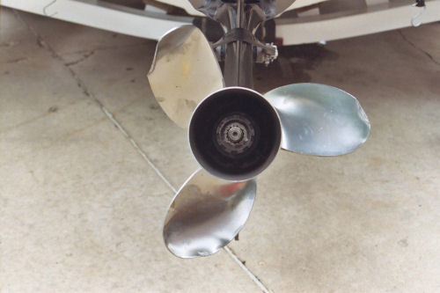

**Figure 2**: Damaged outboard motor propeller **[4]**

Depending on the severity of weed build-up around a motor’s driveshaft and propeller, an operator may be able to manually unwrap or cut tangled weeds. In a typical Ski-Jet, this maintenance is very difficult due to the internal location of the boat’s impellor system. In cases where there is significant weed build-up or damage, a boat may have to be removed from the water and taken to a mechanic for repair. Not only is this a significant source of inconvenience to the watercraft owner but it is a source of additional unneeded expenditure.

Third-party products and solutions designed to aid recreational boat navigators in avoiding or limiting collisions with weeds, rocks, and logs are limited. Frustrated boaters that repeatedly circumvent areas of a lake may wish to resort to a mechanical means to physically remove weeds or obstacles from a specific low-lying area. Mechanical cutters and rakes can rip weeds from the ground near shorelines and may help boaters navigate more freely. In areas where legal, boaters may wish to use selective herbicides and chemicals to permanently kill the plants. Both of these options are harmful to the aquatic ecosystem that exists and are solutions that require significant work by boaters [5]. For boaters that do not wish to disturb the natural aquatic ecosystem, fish finder and sonar systems exist for purchase. These sonar tools are typically marketed to map the depth of a lake or pond and further provide fish finding and tracking abilities. These devices emit a cone of sound waves straight down into water and measure reflected sound waves from the emitted signal to create a sonar map [6]. A typical enthusiast SONAR fish finder is priced in a range of $200USD-$500USD while “Down imaging” fishfinders that provide 3D imaging below a boat can run at prices upwards of $3700USD [7]. These accessories are not directly marketed for collision avoidance or object classification, rather they provide a sonar map to the user and expect them to distinguish which objects may be problematic. The LiDAR BCIS will be designed to directly provide 3D object classification and do so using high-resolution LiDAR. Furthermore, the BCIS is aimed to reduce the financial burden of the competing sonar options by targeting a price range of $300. This should compete with entry-level fish finding devices without breaking the bank.

# **3.0 Method**

The project has multiple hardware and software objectives that must be met in order to be successful. To meet these objectives in an efficient manner, the project will be broken down in a modular manner. The Figure below shows a general breakdown of the system into its initial hardware and software components. The modular manner of the project will allow team members to individually research and experiment with components in parallel without running into conflicts. As each modular component is completed, it can be worked into the final project prototype.

**Table 1:** Modular project breakdown

|  |  |
| --- | --- |
| **Hardware Components** | **Software Components** |
| LiDAR system | General Android application design |
| Bluetooth communication system | Bluetooth connectivity |
| Hardware power system | Attachment arm controls |
| Remotely adjustable attachment arm | Machine Learning model training and deployment |
| 3D printed packaging |  |

Each component of the project presents its own unique challenges. The most notable challenge will be creating a LiDAR system that is both affordable and will provide the 3D scanning techniques necessary to perform object classification. Current 3D lidar products on the market target the commercial and research industries and often have high price tags associated with them. Creating a compatible LiDAR system for the project will involve a significant amount of experimental research. A resource that may be of use to the project is a research paper published in the International Journal of Engineering & Technology that explored the use of cheaper 2D LiDAR sensors for indoor 3D mapping [8].Another challenge to overcome in this section of the project will be choosing a laser that emits light that is not absorbed easily by water. Ideally the green light spectrum with a wavelength of 520nm to 560nm should be chosen for use with underwater LiDAR as its wavelength provides a larger penetration depth than competing ultraviolet light [9].

The project’s use of Machine Learning to perform object classification will also provide a set of unique challenges. Machine Learning is a data-driven activity and as such, the more data that an ML model has to train on, the more effective the ML model will be. In this project, training data will not be available until the LiDAR sensor acts in a state that can provide useful data. In order to keep the project moving at a reasonable pace, machine learning techniques will first be explored using publicly available LiDAR imaging datasets while construction is occurring on the LiDAR module. The Waymo Open 3D LiDAR dataset provides open-source pre-labeled LiDAR images from self-driving cars that can be used to explore machine learning algorithms on [10]. When the LiDAR module is functional, the machine learning techniques that were successful on public datasets can be translated, applied, and evaluated on local training data. Throughout the Machine Learning process, the CRISP-DM data processing methodology will be used. CRISP-DM (Cross-Industry Process for Data Mining) is a methodology that provides a structured approach to any data mining project [11]. The CRISP-DM process is shown in Figure 3 below. For any given project, a Machine Learning engineer should begin by gathering an understanding of project needs, then proceed to gather data and generate a statistical understanding of the data available. Data that is potentially useful for the Machine Learning process is then extracted and manipulated in a step known as feature engineering which prepares data for use with popular Machine Learning libraries and experimental frameworks. Only after all of this is done, will an ML model actually be created and tested. This iterative methodology will ensure that the final ML model is obtained in an orderly and accurate manner.

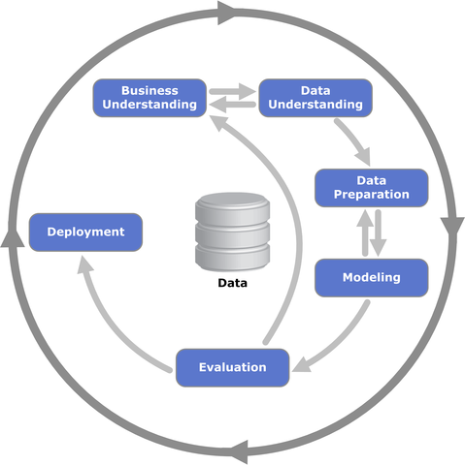

**Figure 3:** CRISP-DM Process Diagram [11]

Testing and evaluation will play a critical role in the project. A successful prototype should be tested on real-world objects like rocks, logs, and weeds. Due to the fact that the majority of the project will be conducted during Canada’s winter season, the option to test using a real-world lake or pond is impractical. Testing and evaluation of the final prototype will be conducted in a simulated environment using an indoor bathtub or pool. Many of the project’s software features can be easily evaluated as “working” or simply “not working”. Evaluating the accuracy of the project’s ML object classification model will require a more thorough evaluation then the rest of the application. While the model will be tested using a set of training data, it is critical that the evaluation data for the model be separate from the training data and be a set of data that the model has never seen before. This will ensure that the ML model has not just memorized the training data but is actually one that is capable of generalizing.

# **4.0 Tools**

During the design and construction of The Boating Collision and Identification System, several hardware and software tools will be used to build and test the system. The hardware portion of the system is expected to consist of three main components that will work together to obtain sensor data and relay the data wirelessly to the software application. A 3D LiDAR sensor or array of 2D LiDAR sensors will be used to obtain LiDAR data. A microcontroller will be used to control the sensor and relay data. An ESP8266 or an Arduino microcontroller board will be sufficient in providing this functionality. Programming the system’s microcontroller will require the Arduino IDE as well as knowledge of the C programming language. Arduino provides high-level C libraries to aid in this process. To relay information to the mobile device, a Bluetooth module must be used. The hardware system on the hull of the boat will require battery power to function. Lithium-Ion 18650 cells can be used in conjunction with a battery management circuit to accomplish this. To add remote control panning ability to the LiDAR control unit, a servomotor will be required. To create the prototype, several lab tools such as soldering irons, prototype boards, multimeters, and oscilloscopes will be used. A finished prototype will require a 3D printed housing that must be designed using CAD software. TinkerCAD provides a free online CAD tool that can be used to design the housing [12].

The BCIS’s Android application consists of the majority of the project’s software features. The general Android application will be written in Java and will utilize Google’s official Android Studio integrated development environment. This IDE makes integrating applications with Android smartphones convenient by providing virtual smartphone emulators and providing Android SDK toolkits out of the box. Android Studio is a multiplatform application and provides the ability to link to GitHub. GitHub will play a critical role in sharing code between team members and allows for convenient version control. Google’s Android Developer Documentation provides resources for developers looking to increase their breadth of knowledge on Android’s SDKs as well as all app building fundamentals [13].

A trained Machine Learning model will be used by the user’s smartphone to perform object classification based on input data from the system’s LiDAR module. When creating, evaluating, and deploying the Machine Learning model, Google’s industry-leading open-source TensorFlow library will be used. TensorFlow provides a Python API for loading & preprocessing data as well as building, training, and reusing models [14]. To deploy models to an edge device, the TensorFlow Lite API for Java can be used. TensorFlow’s developer documentation provides the best source of information for gaining information about TensorFlow’s API methods and features. TensorFlow’s Community forums provide a chance to actively interact with other ML developers and gain debugging tips [15]. When training ML models it may be advantageous to make use of cloud computing to gain access to increased computing resources. Google Cloud Compute (GCP) offers access to virtual machines that can use Google provisioned GPUs and TPUs for increased performance [14].

# **5.0 Expected Results**

Upon the conclusion of the project, the group expects to have a working prototype of a wireless LiDAR object classification system for detecting logs, rocks, and weeds. The working prototype should prove that LiDAR can be successfully used for gathering data in an aquatic environment. The prototype should also demonstrate the power of ML models that are deployed on edge devices. The prototype will provide a demonstration that recreational boaters can use alternatives to generic fish-finding products for avoiding objects. The product should help lake goers rethink their decisions before deciding to mechanically or chemically remove weeds from an ecosystem because they get in the way of boats.

The Boating Collision and Identification System’s Android application will act as a cheap navigation device that will help cut down the financial impact that expensive sonar & GPS systems have on recreational boaters that are interested in improving navigation. Using an Android device for remote processing will cut down on the economic impact of the project and will also cut down on the electronic waste present during the final stage of the system’s lifecycle.

As the project will use an ML model to perform object classification of four separate categories (rocks, logs, weeds, no obstacles) we should expect that the model will perform with an accuracy that is much better than 25%. This would indicate that the model has actually learned the feature parameters of the objects it is classifying instead of just making a random guess. A final product that provides a percent confidence figure alongside its object classification will provide users with increased confidence in their navigation capabilities.

# **6.0 Management and Time Table**

## ***6.1 Group Management and Expectations***

In order for the project to be successfully completed in an efficient and effective manner, a thorough timetable and management plan has been agreed upon and set in place by the project group. Due to the ongoing COVID-19 pandemic, the project will be conducted remotely by five members. This unfortunate circumstance makes an effective communication channel extremely important. The group has established a Facebook group messaging channel. This should allow for quick communication between group members by means of instant messages. While this communication method should be useful for quick interactions, it does not lend itself well to situations in which more substantial technical information must be shared between team members. To solve this problem, bi-weekly group Zoom meetings have been scheduled for 11:30AM on Monday mornings. This meeting will cover the accomplishments of the previous two weeks and will address the current week’s objectives. This meeting will provide a chance for group members to share any difficulties they have been having and will provide an opportunity to receive advice from team members.

The Boating Collision and Identification System will require several individual parts that must work in unison to create a successful prototype. To accomplish the project objectives, the project group has broken down the project into several smaller steps. Each group member has been assigned a role that corresponds to one of the steps required to build the system. Every member has been given second and third priorities that can be worked on simultaneously during the project.

**Table 2:** Project breakdown with group member role assignments and priorities

|  |  |  |  |  |  |
| --- | --- | --- | --- | --- | --- |
| **Priority** | **Jonathan** | **Daniel** | **Sean** | **Kingsley** | **Farhan** |
| **#1** | Power Distribution System | Lidar Sensor System | Machine Learning Model | General Application Construction | Lidar Software Integration |
| **#2** | Lidar Sensor System | Power Distribution System | Controlling Arm Integration | Bluetooth Communication | Controlling Arm Integration |
| **#3** | Controlling Arm | Controlling Arm | 3D Packaging | 3D Packaging | 3D Packaging |

The group has also created a project timeline that will be relied upon in order to track project progress and track important project deliverables such as the December progress report, final report, and poster presentation. The Gantt chart below depicts the month-by-month project breakdown that is expected by the group.

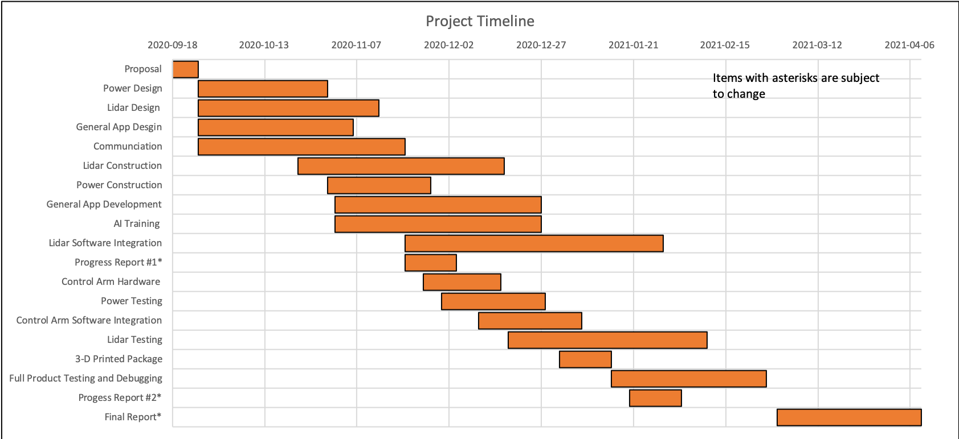

**Figure 3:** Gantt chart of project timeline

## ***6.2 Individual Machine Learning Timeline***

The Machine Learning aspect of the project will be used to classify objects viewed by the LiDAR sensor located on the hull of the boat. To accomplish this specific task, a more detailed approach timeline has been created. This timeline accounts for market research, data manipulation, model design, deployment, and testing. The Gantt chart below depicts this expected timeline for these aspects of the project. Due to the fact that Machine Learning is very experimental in nature, the majority of the timeline is allocated towards researching and experimenting with different learning algorithms.

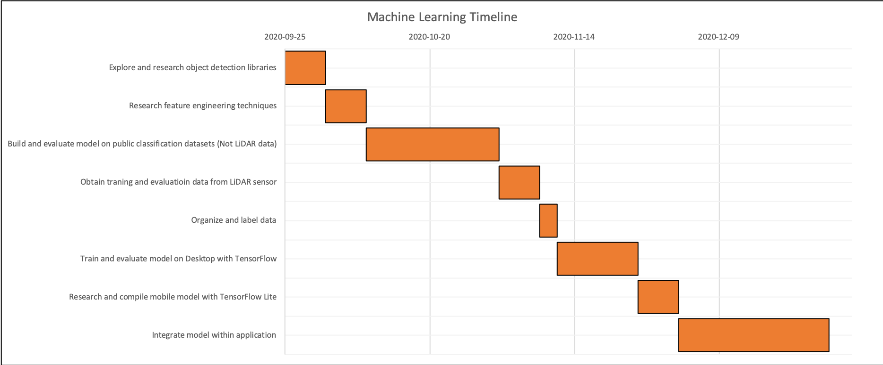

**Figure 4:** Project's Machine Learning timeline

# 

# **7.0 References**

[1] “Putting Dollars to Horses Outboard engine price comparison,” *Pontoon Boat Magazine*. [Online]. Available: https://www.pdbmagazine.com/2011/06/putting-dollars-to-horses. [Accessed: 27-Sep-2020].

[2] Steven, “How Much Does a Jet Ski Cost? 2020 Jet Ski Prices,” *Steven in Sales*, 02-Sep-2020. [Online]. Available: https://www.steveninsales.com/much-jet-ski-cost/. [Accessed: 27-Sep-2020].

[3] “How Does a Jet Ski Work? Jet Ski Engine and Pump Explained,” *JetDrift*, 19-May-2020. [Online]. Available: https://www.jetdrift.com/how-does-a-jet-ski-work/. [Accessed: 27-Sep-2020].

[4] “Damaged Prop: Repair or Replace?,” *BoatTEST*, 04-Nov-2019. [Online]. Available: https://www.boattest.com/view-news/3421_damaged-prop-repair-or-replace. [Accessed: 24-Sep-2020].

[5] E. Capkin, I. Altinok, and S. Karahan, “Water quality and fish size affect toxicity of endosulfan, an organochlorine pesticide, to rainbow trout,” *Chemosphere*, vol. 64, no. 10, pp. 1793–1800, 2006.

[6] “Quick Tutorial on How Fish Finder Works,” *Deeper Smart Sonar: Castable Fish Finder Perfect for Any Fishing Type*. [Online]. Available: https://deepersonar.com/us/en_us/how-it-works/how-sonars-work. [Accessed: 24-Sep-2020].

[7] Staff, “How much does a fish finder cost? We review prices on different types,” *How much is that?*, 19-Jan-2020. [Online]. Available: https://www.helpfulprice.com/how-much-does-a-fish-finder-cost-we-review-prices-on-different-types/. [Accessed: 24-Sep-2020].

[8] M. R. Shahrin, F. H. Hashim, W. M. Zaki, A. Hussain, and T. T. Raj, “3D Indoor Mapping System Using 2D LiDAR Sensor for Drones,” *International Journal of Engineering & Technology*, vol. 7, no. 4.11, p. 179, 2018.

[9] K. Hardy, L. Sanches, and J. Sanderson, “Diode Lasers in Underwater Applications,” *DeepSea Power & Light*, 12-Feb-2019. [Online]. Available: https://www.deepsea.com/knowledgebase/technical-resources/diode-lasers-in-underwater-applications/. [Accessed: 29-Sep-2020].

[10] “Data,” *Waymo*, 2020. [Online]. Available: https://waymo.com/open/data/. [Accessed: 27-Sep-2020].

[11] The CRISP DM data mining methodology. (n.d.). Retrieved August 11, 2020, from https://smartvision-me.com/the-crisp-dm-data-mining-methodology/

[12] “Learn how to use Tinkercad,” *Tinkercad*. [Online]. Available: https://www.tinkercad.com/learn/designs. [Accessed: 27-Sep-2020].

[13] “API reference  :   Android Developers,” *Android Developers*. [Online]. Available: https://developer.android.com/reference. [Accessed: 27-Sep-2020].

[14] A. Unruh, “What is the TensorFlow machine intelligence platform?,” *Opensource.com*, 09-Nov-2017. [Online]. Available: https://opensource.com/article/17/11/intro-tensorflow. [Accessed: 27-Sep-2020].

[15] “API Documentation  :   TensorFlow Core v2.3.0,” *TensorFlow*, 2020. [Online]. Available: https://www.tensorflow.org/api_docs. [Accessed: 27-Sep-2020].